38.20: a) Equating initial kinetic energy and final potential energy and solving for the separation radius r,
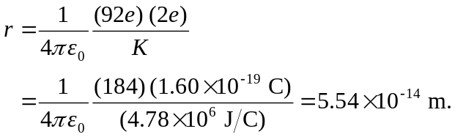
b) The above result may be substituted into Coulomb’s law, or, the relation between the magnitude of the force and the magnitude of the potential energy in a Coulombic field is
